**Batch: A2**

**Roll No.: 16010123032**

**Experiment / assignment / tutorial No. 5**

**Grade: AA / AB / BB / BC / CC / CD /DD**

**Signature of the Staff In-charge with date**

**Title:**

Implementation of Queue operations (Static and Dynamic implementation)- Queue,

circular queue, priority queue, and deque

**Objective:** To implement Basic Operations of Queues

# Expected Outcome of Experiment:

|  |  |
| --- | --- |
| **CO** | **Outcome** |
| **2** | Apply linear and non-linear data structure in application development. |

**Books/ Journals/ Websites referred: Introduction:**

*(diagram of queue)*

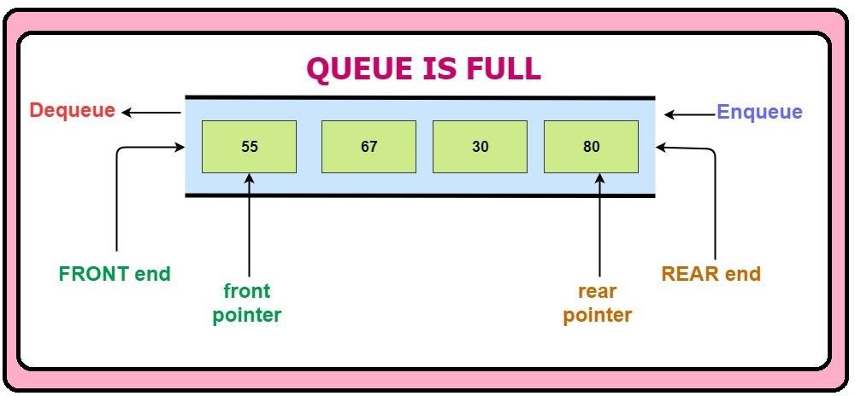

## Program source code:

1. **Queue Using Array** #include <stdio.h> #include <stdlib.h> #define MAX 5

int queue[MAX];

int front = -1, rear = -1; void insert() {

if (rear == MAX - 1) { printf("Queue is full\n"); return;

}

int data; printf("Enter data: "); scanf("%d", &data); if (front == -1) {

front = 0;

rear =0;

}

queue[rear++] = data;

printf("Element inserted successfully.\n");

}

void delete() {

if (front == -1 || front > rear) { printf("Queue is empty!\n"); return;

}

printf("Deleted element: %d\n", queue[front]); front++;

if (front > rear) { front = rear = -1;

}

}

void display() {

if (front == -1 || front > rear) { printf("Queue is empty!\n"); return;

}

printf("Queue elements:\n");

for (int i = front; i <= rear; i++) { printf("%d ", queue[i]);

}

printf("\n");

}

int main() { int choice;

printf("MENU\n"); while (1) {

printf("1. Insert\n2. Delete\n3. Display\n4. Exit\n"); printf("Enter your choice: ");

scanf("%d", &choice); switch (choice) {

case 1:

insert();

break; case 2:

delete(); break;

case 3:

display(); break;

case 4:

printf("Exiting...\n"); exit(0);

default:

printf("Invalid choice\n");

}

}

return 0;

}

## Queue using Linked list

#include <stdio.h> #include <stdlib.h> typedef struct node {

int data;

struct node *next;

}node;

node *front = NULL; node *rear = NULL; void insert() {

node *ptr;

int item;

ptr = (node *)malloc(sizeof(node)); if (ptr == NULL) {

printf("Memory allocation failed.\n"); return;

}

printf("Enter value: "); scanf("%d", &item); ptr->data = item;

ptr->next = NULL; if (front == NULL) {

front = ptr; rear = ptr;

} else {

rear->next = ptr; rear = ptr;

}

printf("Element inserted.\n");

}

void delete() { node *ptr;

if (front == NULL) { printf("\nQueue Underflow.\n"); return;

} else {

ptr = front;

front = front->next;

free(ptr);

}

if (front == NULL) { rear = NULL;

}

printf("Element deleted.\n");

}

void display() { node *ptr;

if (front == NULL) { printf("\nQueue is empty.\n");

} else {

printf("Queue contents:\n"); ptr = front;

while (ptr != NULL) { printf("%d ", ptr->data); ptr = ptr->next;

}

}

printf("\n");

}

void exitProgram() { node *temp;

while (front != NULL) { temp = front;

front = front->next; free(temp);

}

rear = NULL; printf("\nExited program"); exit(0);

}

int main() {

int choice = 0; printf("MENU"); while (1) {

printf("\n1. Insert an element\n2. Delete an element\n3. Display the queue\n4. Exit\n"); printf("Enter your choice: ");

scanf("%d", &choice); switch (choice) {

case 1:

insert(); break;

case 2:

delete(); break;

case 3:

display(); break;

case 4:

exitProgram(); break;

default:

printf("\nInvalid choice\n");

break;

}

}

return 0;

}

## Circular Queue

#include <stdio.h> #include <stdlib.h> #define MAX 5

int CQ[MAX];

int front = -1, rear = -1; void insert() {

int val;

if ((front == 0 && rear == MAX - 1) || (rear == (front - 1) % (MAX - 1))) { printf("Queue is full\n");

return;

} else {

printf("Enter the value to insert: "); scanf("%d", &val);

if (front == -1) { front = rear = 0;

} else if (rear == MAX - 1 && front != 0) { rear = 0;

} else {

rear++;

}

CQ[rear] = val;

printf("Inserted : %d\n", val);

}

}

void delete() {

if (front == -1) { printf("Queue is empty\n"); return;

}

int val = CQ[front]; if (front == rear) {

front = rear = -1;

} else if (front == MAX - 1) { front = 0;

} else {

front++;

}

printf("Deleted : %d\n", val);

}

void display() {

if (front == -1) { printf("Queue is empty\n"); return;

}

printf("Queue elements are:\n"); int i;

if (rear >= front) {

for (i = front; i <= rear; i++) { printf("%d ", CQ[i]);

}

} else {

for (i = front; i < MAX; i++) { printf("%d ", CQ[i]);

}

for (i = 0; i <= rear; i++) { printf("%d ", CQ[i]);

}

}

printf("\n");

}

void EXIT(){ printf("Program exited.\n"); exit(0);

}

int main() { int choice;

printf("MENU"); while (1) {

printf("\n1. Insert an element\n2. Delete an element\n3. Display the queue\n4. Exit\n"); printf("Enter your choice: ");

scanf("%d", &choice); switch (choice) {

case 1:

insert();

break; case 2:

delete(); break;

case 3:

display(); break;

case 4:

EXIT();

break; default:

printf("Invalid choice\n");

}

}

return 0;

}

## Doubly – ended Queue

#include <stdio.h> #include <stdlib.h> #define MAX 10 int deque[MAX];

int front = -1, rear = -1; void insert() {

int val, choice;

if ((front == 0 && rear == MAX - 1) || (front == rear + 1)) { printf("Deque is full\n");

return;

}

printf("Enter the value to insert: "); scanf("%d", &val);

printf("Where do you want to insert the value?\n1. Front\n2. Rear\n"); printf("Enter your choice: ");

scanf("%d", &choice); if (choice == 1) {

if (front == -1) { front = rear = 0;

} else if (front == 0) { front = MAX - 1;

} else {

front--;

}

deque[front] = val;

printf("Inserted %d at the front\n", val);

} else if (choice == 2) { if (rear == -1) {

front = rear = 0;

} else if (rear == MAX - 1) { rear = 0;

} else {

rear++;

}

deque[rear] = val;

printf("Inserted %d at the rear\n", val);

} else {

printf("Invalid choice!\n");

}

}

void delete() { int choice;

if (front == -1) { printf("Deque is empty!\n"); return;

}

printf("From where do you want to delete the value?\n1. Front\n2. Rear\n"); printf("Enter your choice: ");

scanf("%d", &choice); if (choice == 1) {

int val = deque[front]; if (front == rear) {

front = rear = -1;

} else if (front == MAX - 1) { front = 0;

} else {

front++;

}

printf("Deleted %d from the front\n", val);

} else if (choice == 2) { int val = deque[rear]; if (front == rear) {

front = rear = -1;

} else if (rear == 0) {

rear = MAX - 1;

} else {

rear--;

}

printf("Deleted %d from the rear\n", val);

} else {

printf("Invalid choice!\n");

}

}

void display() {

if (front == -1) { printf("Deque is empty!\n"); return;

}

printf("Deque elements are:\n"); int i = front;

if (front <= rear) { while (i <= rear) {

printf("%d ", deque[i++]);

}

} else {

while (i <= MAX - 1) { printf("%d ", deque[i++]);

}

i = 0;

while (i <= rear) { printf("%d ", deque[i++]);

}

}

printf("\n");

}

int main() { int choice; while (1) {

printf("\n1. Insert an element\n2. Delete an element\n3. Display the queue\n4. Exit\n"); printf("Enter your choice: ");

scanf("%d", &choice); switch (choice) {

case 1:

insert(); break;

case 2:

delete(); break;

case 3:

display(); break;

case 4:

printf("Exited program\n"); exit(0);

default:

printf("Invalid choice\n");

}

}

return 0;

}

**Output Screenshots: 1)**

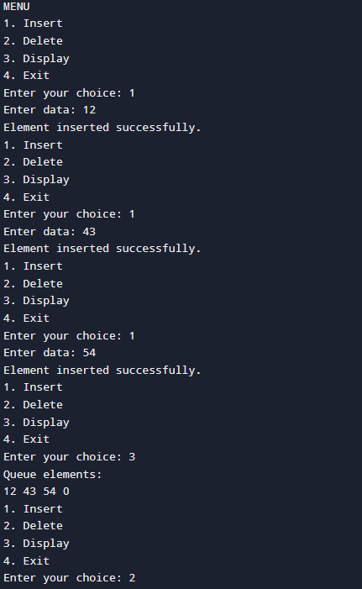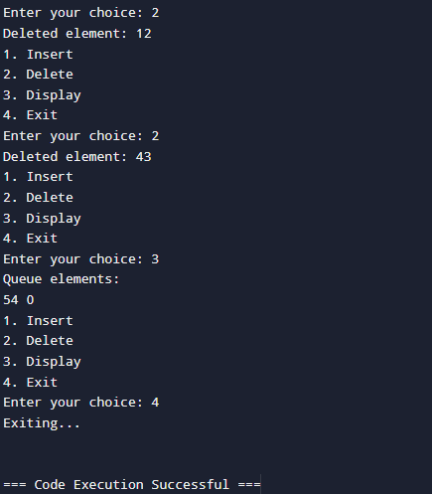

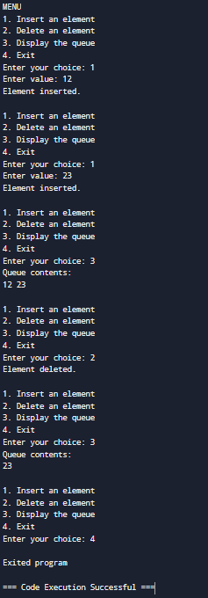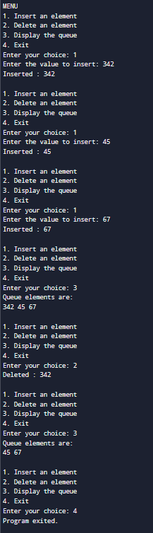2) 3)

4)

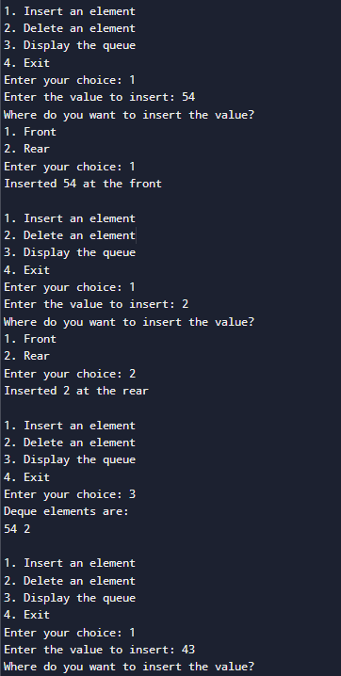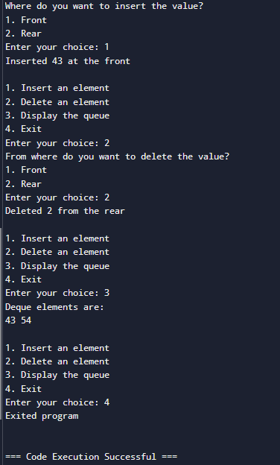

# Conclusion:

We learned to implement different types od Queues.

# Post lab questions:

1. What are the key considerations in choosing between a circular array and a linked list for the implementation of a queue?

Key considerations when choosing a circular array include:

Fixed size with faster access due to contiguous memory, making it cache-friendly. Limited by predefined capacity, making it efficient for small or fixed-size queues. Simple to implement but requires careful handling of wrap-around logic.

Key considerations when choosing a linked list include: Dynamic size without a fixed limit, offering flexibility.

Slower due to pointer traversal and additional memory overhead for storing pointers.

Suitable for queues with unpredictable or large size variations, though implementation is more complex.

1. Implementation of Priority Queue. #include <stdio.h>

#include <stdlib.h> #define MAX 10 int queue[MAX]; int priority[MAX]; int size = 0;

void insert() {

if (size == MAX) { printf("Queue is full\n"); return;

}

int data, pr; printf("Enter data: "); scanf("%d", &data); printf("Enter priority: "); scanf("%d", &pr);

int i = size - 1;

while (i >= 0 && priority[i] < pr) { queue[i + 1] = queue[i]; priority[i + 1] = priority[i];

i--;

}

queue[i + 1] = data; priority[i + 1] = pr; size++;

printf("Element inserted successfully.\n");

}

void deleteMax() { if (size == 0) {

printf("Queue is empty!\n"); return;

}

printf("Deleted element with data: %d, priority: %d\n", queue[0], priority[0]); int i;

for (i = 1; i < size; i++) { queue[i - 1] = queue[i]; priority[i - 1] = priority[i];

}

size--;

}

void display() { if (size == 0) {

printf("Queue is empty!\n"); return;

}

printf("Priority Queue:\n"); int i;

for (i = 0; i < size; i++) {

printf("Data: %d, Priority: %d\n", queue[i], priority[i]);

}

}

int main() { int choice;

printf("MENU"); while (1) {

printf("\n1. Insert an element\n2. Delete an element\n3. Display the queue\n4.

Exit\n");

printf("Enter your choice: "); scanf("%d", &choice); switch (choice) {

case 1:

insert(); break;

case 2:

deleteMax(); break;

case 3:

display();

break; case 4:

printf("Exited program\n"); exit(0);

default:

printf("Invalid choice! Try again.\n");

}

}

return 0;

